Analysis of Product Quality, Service Quality, and Customer Satisfaction at Waroeng Special Sambal "SS” West Jakarta
*Corresponding Author
ARTICLE INFO |  | ABSTRACT
Article history  Received 22 February 2022  Revised 10 March 2022  Accepted 28 March 2022 |  | This study aims to analyze the effect of product quality and service quality on customer satisfaction at Waroeng Special Sambal customers in West Jakarta. The variables used in this study are product quality and service quality as exogenous, and customer satisfaction as endogenous. The sample selection used probability sampling method with incidental sampling technique and the sample in this study were 120 respondents who were customers of Waroeng Special Sambal in West Jakarta. The data processing method used is the Structural Equation Modeling (SEM) method using IBM AMOS 22 software.  The results of this study indicate that product quality has a positive and significant effect on customer satisfaction with an estimated value of 0.302, where these results prove that food and beverage products at Waroeng Special Sambal produce satisfaction from their customers. Then the following results show that Service Quality has a positive and significant effect on Customer Satisfaction with an estimated value of 0.503, where these results prove that the services provided by the employees or the Waroeng Special Sambal facilities have resulted in satisfaction from their customers.
Keywords
Product Quality ;
Service Quality ;
Customer Satisfaction ;

INTRODUCTION
One of the many businesses that are growing rapidly even in times of crisis is the culinary business. Because basically food is one of the basic human needs that must be met, so if food and beverages are still a priority, the culinary business will continue to grow and develop. The development of the culinary business is followed by many restaurants that have sprung up such as regular restaurants, fast food restaurants and complete restaurants. The menus and facilities offered are also growing, ranging from places to simply enjoy home cooking with simple menus to luxury restaurants serving a variety of unique and international menus.
When consumers do culinary, of course they will choose a restaurant that can provide satisfying products and services according to their wishes. So many restaurants are competing to create products and provide maximum service to their customers. However, even though it has good quality products and services, it does not necessarily make consumers satisfied. According to (Cucu Sumartini & Fajriany Tias, 2019) that customer satisfaction is a feeling of pleasure or disappointment for customers and is a comparative assessment that arises after a comparison between perceptions of the performance of a product and its expectations. (Sumartini's grandson & Fajriany Ardining Tias, 2019) This means that if customer satisfaction is achieved, it means that product quality and service quality can meet consumer expectations, causing consumers to make repeat purchases and increase the number of sales.
The quality of products and services rests on efforts to satisfy customer desires or demands based on customer expectations. Companies must provide satisfaction to their customers if they want to win the competition, because if customers are not satisfied, they will leave the company and move to become customers of competing companies. (Supranto, 2011:12).
Waroeng Special Sambal "SS" is one of the restaurant brands that serves a variety of fresh chili and Indonesian specialties. In 2002, Mr. Yoyok Hery Wahyono founded the first Waroeng Special Sambal "SS" in Yogyakarta with the Waroeng Tent concept which has a characteristic in the form of a menu of various kinds of chili sauce. Special Waroeng Sambal "SS" has 98 branches spread across several regions in Indonesia. Waroeng Branch Special Sambal "SS" in this study is located in Grogol Petamburan, Tanjung Duren Utara in West Jakarta. Waroeng Special Sambal "SS" in West Jakarta provides a variety of chili sauce and side dishes. Waroeng Special Sambal "SS" in West Jakarta provides a variety of choices of chili sauce and side dishes. The first step taken by Waroeng Special Sambal "SS" in West Jakarta in attracting customers who love spicy dishes by issuing the slogan "Pedas Abis" But behind it there are some opinions from the authors' friends as a special Waroeng customer Sambal "SS" said about the experience they got while visiting Waroeng's special restaurant Sambal "SS" in West Jakarta, that the product from Waroeng Special Sambal "SS" on West Jakarta is basically quite varied and delicious, but complaining about sambal, sometimes less consistent, spicy taste is sometimes less spicy or not spicy. Some employees often do not provide greetings to consumers when they enter Waroeng Special Sambal "SS", and sometimes employees do not tell first that food / beverage stocks have run out when customers have been waiting for orders, and lack of comfort at the time of the queue because the waiting chair provided is very lacking and slowly presents orders given to customers.
From the problems and gaps above, this study aims to determine the effect of product quality and service quality partially on customer satisfaction at Waroeng Special Sambal "SS" West Jakarta, and intends to re-clarify the determinants of customer satisfaction so that it can contribute to Waroeng Special Sambal "SS" in West Jakarta to be considered in carrying out marketing strategies related to these determining factors.

METHOD
Product Quality
A product according to (Kotler & Armstrong, 2001) in (Faradiba & Astuti, 2013) is something that can be offered to the market to get attention, be purchased, used, and consumed by customers so as to satisfy their wants or needs. Product quality according to (Kotler and Armstrong, 2004:283) in (Widjoyo, 2014) is a characteristic of goods and services that have reliability, accuracy, convenience, maintenance, ability to meet needs, and other attributes of a product. The product quality is compatibility and conformity with applicable specifications and standards, suitable or satisfied for use, can satisfy desires, meet needs and expectations at competitive costs (Hutchin, 2002:287). A product that has good quality will certainly give satisfaction to customers. If this can be maintained by producers, it will provide benefits in terms of financial and customer loyalty.
The quality of food products is somewhat different from the quality of goods because the quality of food is directly perceived by consumers. According to (Bartono,2005) in suggests that "the quality of food is determined by several quality indicators including: 1) Good and appropriate portions with standard serving portions, 2) Delicious taste because of the right recipe standards, 3) Appearance that is good on a plate, 4) A high level of hygiene and cleanliness, 5) Punctuality or the right timing in serving.
Service Quality
Service quality is a customer's assessment of the quality of service received and felt based on what is imagined in his mind. Quality of service is the benefit that a company offers to consumers, which is essentially intangible and does not result in the ownership of anything. According to (Tjiptono.2007) in (Ibrahim & Thawil, 2019) explains that service quality is a form of company efforts to meet consumer needs and desires as well as supply accuracy and balance to consumer expectations. Customers will turn to service providers who are better able to understand their specific needs and provide better service. The dimensions of service quality according to (Lupiyoadi, 2013) in (Trianah et al., 2017) consist of: 1) Tangible, which focuses on physical elements of service such as physical facilities, location, equipment, and equipment used, 2) Reliability, is the ability to provide services. to what has been promised in accordance with customer expectations, such as timeliness, the same service to all customers, a sympathetic attitude and high accuracy, 3) Responsiveness, namely the willingness to help and provide fast and precise service to customers with clear information, 4) Assurance, is the ability of employees to create and grow customer trust and confidence in the company, 5) Empathy, is sharing what is thought, felt, and the situation experienced by customers including concern for customer knowledge, desires, and needs.
Customer Satisfaction
According to (Kotler & Keller, 2016:138) that customer satisfaction is the feeling of pleasure or disappointment of a customer that arises after comparing expectations with the reality obtained. High customer satisfaction or pleasure creates an emotional bond with them or the company concerned. Meanwhile, according to (Tjiptono & Chandra, 2012 p.59) in (Mahira et al., 2021) states that customer satisfaction is the customer's emotional response to aspects such as expectations of the product, the experience of using the product, and so on. The response occurs at certain times such as after choosing or using the product. The definition of customer satisfaction according to (Alma Buchori, 2011) in (Gunawan et al., 2020), is a function of perceived performance and expectations. If the product or service purchased is in accordance with what consumers expect, it will get satisfaction. Conversely, if the product or service purchased is not in accordance with what consumers expect, dissatisfaction and feelings of disappointment will arise.
Based on the opinions of the experts mentioned above, it can be seen that customer satisfaction is closely related to two things, namely: expectations and results received by consumers. The characteristics of satisfied consumers according to (Kotler & Keller, 2016: 48), are as follows: 1) Loyal to products and services, 2) There is positive word communication, 3) The existence of the company is considered the main thing in buying products or services.
Product Quality and Customer Satisfaction
Previous research conducted (Yungga & Sunarsi, 2020) concluded that hypothesis testing (t test) of product quality had a significant effect on customer satisfaction. Similarly, the research conducted (Khasan et al., 2021) concluded that there was a partial effect of Product Quality and Service Quality variables on Consumer Satisfaction. The results of hypothesis testing in research (Khairusy & Febriani, 2020) conclude that product quality affects customer satisfaction. Testing the research hypothesis (Hartadi & Husda, 2020) also stated that there was a positive and partially significant effect between product quality on customer satisfaction.
H1: Product quality partially positive and significant effect on customer satisfaction.

Service Quality and Customer Satisfaction
Hypothesis testing in research (Asti & Ayunungtyas, 2020) concluded that service quality has a significant effect on customer satisfaction in a positive direction, meaning that the higher the quality of service provided, the higher the customer satisfaction. Similarly, the results of the research hypothesis testing conducted (Santoso & Khuzaini, 2021) concluded that service quality has a positive and significant effect on customer satisfaction. (Santoso & Khuzaini, 2021).
The conclusion of the research (Ilmi & Khuzaini, 2021) states that the service quality variable has a positive and significant effect on customer satisfaction Customers have a positive response to the quality of service provided by the company, meaning that if there is an increase in the quality of service to customers, it will have an impact on customer satisfaction, because customers always judge a service received with customer expectations.

H2: Service quality partially has a positive and significant effect on customer satisfaction.

The conceptual framework of this research is as follows:
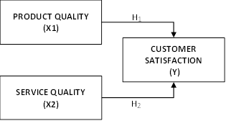

Source: Development of the researcher.
Figure 1 Conceptual Framework.

RESULT
Research Design
This research is a quantitative and causal research with Structural Equation Modeling (SEM) as a data analysis technique. According to (Sugiono, 2010) that the SEM technique is basically to get a structural model. The obtained model can be used for prediction or model proof.
Population and Sample
The population according to (Husein Umar, 2002:136) in (Sasangka & Rusmayadi, 2018) is a collection of groups that have the same characteristics and opportunities to be selected as sample members. The population of this research is the customers of Waroeng Special Sambal "SS" in West Jakarta. The sampling method used probability sampling with incidental sampling technique, where every customer who happened to meet the researcher and was deemed worthy could be used as a sample (Sugiyono.2016:85). The sample size of this study uses a minimum sample, namely the number of indicators multiplied by 5 to 10 for each parameter estimated (Hair, 2010:176) in (Setyo, 2017). The sample of this research that is fulfilled is 20 x 6 = 120 samples.
Operationalization and Measurement of Variables
The data measurement method used a Likert scale. According to (Maholtra, 2016: 282), each statement item has seven levels of measurement from (1) to (6). The questionnaires obtained from the respondents were 120 questionnaires and none of the questionnaires were canceled.
Analysis Techniques
The data processing method uses Structural Equation Modeling (SEM). According to (Ghozali, 2011) in (Fitriyana et al., 2013) that SEM can jointly test the structural model of the relationship pattern between exogenous and endogenous latent constructs. The stages are model specification, identification, estimation, and fit testing. The application used to process data and statistical analysis is IBM SPSS AMOS 22.

DISCUSSION
The specification of this research model consists of 3 variables, 2 hypotheses, and 20 indicators. After processing the data, it shows that all indicators in the study meet the requirements, so that all indicators are tested at a later stage whether there is a relationship between the variables in the model. According to (Hair, 2010: 193) each construct must have 3 indicators and both have 4 indicators.
Constructions that have less than 3 indicators will be under-identified. To identify the model, there are 3 categories as determining factors, namely under-identified, just-identified, and over-identified. To determine the category of data owned, it can be done by looking at the Degrees of Freedom contained in table 1.
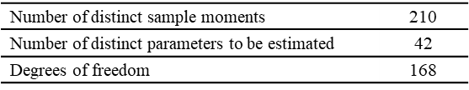
Table 1 Computation Degree of Freedom.

Source: Results of data processing with AMOS 22.
In table 1, it can be explained that the model category is the result of Degree of Freedom (DF > 0), so that the data is included in the over-identified and positive category. The next stage is re-testing the validity and reliability tests on all respondents obtained through online questionnaires.
Validity and Reliability Test (Pre-Test)
Before distributing all indicators, validity and reliability tests were carried out on several indicators as an initial test. The sample needed to test the initial indicators is 30 respondents (Sujarweni 2015: 192). The validity test results (Pre-Test) are presented in Table 2.

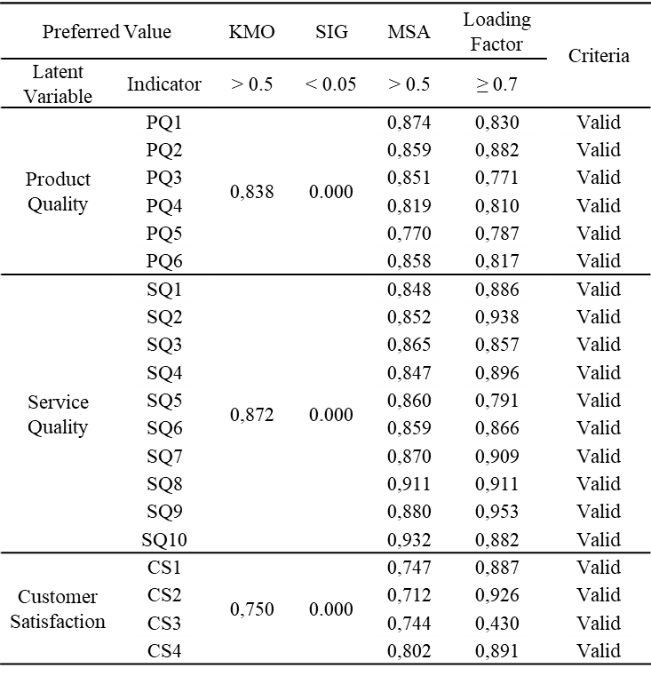
Table 2 Validity Test Result (Pre-Test).

Source: Results of data processing with SPSS 23.
Table 2 explains the results of the Pre-test Validity Test, that all Product Quality, Service Quality and Customer Satisfaction indicators are declared valid, because they meet the requirements for KMO value > 0.5, significance < 0.005, MSA value > 0.5, loading factor ≥ 0, 7.
To measure the consistency of the indicator construct used reliability test. The limit value is seen from Cronbach's Alpha (0.70), if it exceeds the limit, it is declared reliable, consistent and relevant to the variable The results of the reliability test (pre-test) are in Table 3.
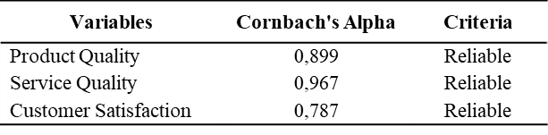
Table 3 Reliability Test Results (Pre-Test).

Source: Results of Data Processing with SPSS 23.
Validity and Reliability Test (Measurement)
According to (Hair et al, 2014) in (Sudirman et al., 2020), that a variable that has good validity is having a standardized loading factor (SLF) ≥ 0.5. However, SLF has an ideal value of ≥ 0.7. If a variable has a standardized factor loading ≥ 0.5 then the variable can be said to have good validity. The reliability test was carried out by looking at the Average Variance Extended (AVE) and Construct Reliability (CR) values. Each value has good reliability if AVE ≥ 0.5 and CR ≥ 0.7 [24] The validity test and the reliability test (measurement) can be seen in table 4.
Table 4 Validity and Reliability Test – Measurement
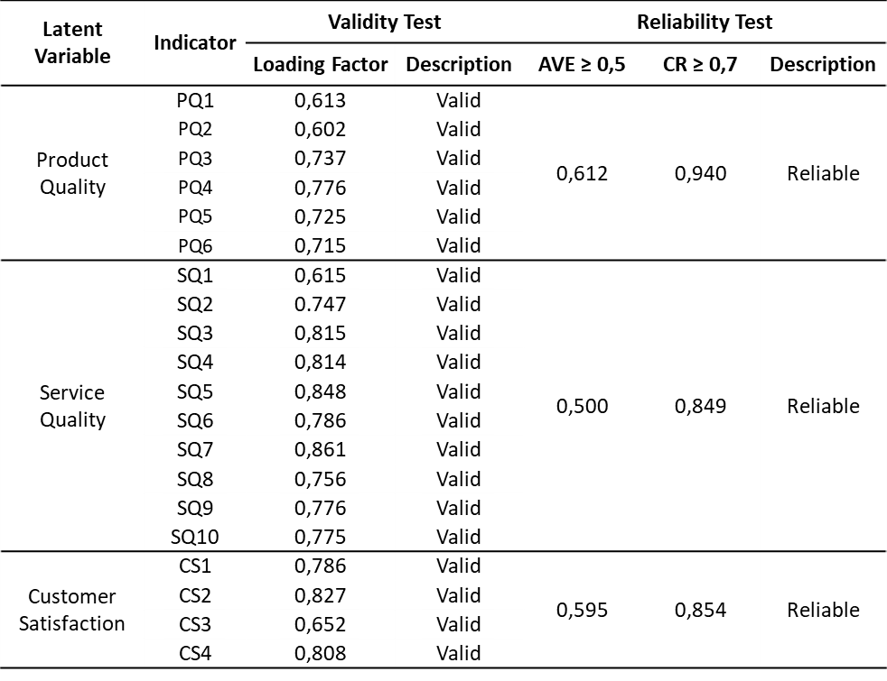

Source: Results of data processing with AMOS 22.
Table 5 shows that all indicators of each variable are declared valid and reliable because validity meets the required standards having a factor loading ≥ 0.5 and reliability having AVE ≥ 0.5 and CR ≥ 0.7.
Goodness of Fit (GOF)
The Goodness of Fit test is to find out the specifications of the model with sample data. GOF evaluation is carried out through several levels, namely overall model fit, measurement model fit, and structural model fit. From this test, it can be determined how well the research model specifications are with the sample data or observed (Santoso,2011) in (Siagian & Wijoyo, 2021) [25] The evaluation model can be said to be good fit if it has a value of The Minimum Sample Discrepancy Function (CMIN/DF) ≤ 2.0, Goodness of Fit Index (GFI) ≥ 0.90, The Root Mean Square Error of Approximation (RMSEA) ≤ 0.08, and Adjusted Goodness of Fit (AGFI) ≥ 0.90. Table 5 describes the results of the analysis of several GOF indices.
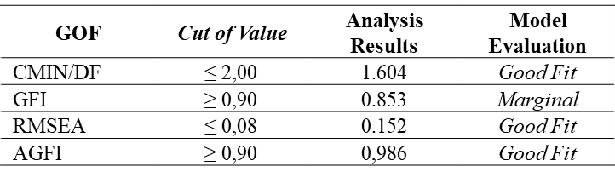
Table 5 Goodness of Fit Research Results

Source: Results of data processing with AMOS 22.
Table 5 explains that the CMIN/DF index has a good fit model evaluation, because the cut of value index of 1.604 is less than the standard indicated ≤ 2.0. The GFI index has a marginal model evaluation, because the cut of value index of 0.853 is below the implied standard of ≥ 0.90. The RMSEA index has a good fit model evaluation, because the cut of value index is 0.068 which is lower than the required standard ≤ 0.08. Meanwhile, AGFI has an evaluation of the Good Fit model of 0.986 because the cut of value index is higher than the standard indicated ≥ 0.90. These results show that almost all of the model fit criteria are already on the good fit criteria, but there are some model fit criteria that are still on the marginal criteria.
Hypothesis Test Results
Hypothesis testing was carried out to determine the significance by looking at the value (𝜌) of the overall model on the variables that have causality between endogenous and exogenous variables. The results of hypothesis testing are determined by looking at the estimated value and 𝜌. If the estimated value is positive and 𝜌 < 0.05, then the hypothesis is proven to be significant and is supported by the data (Ho is rejected). Meanwhile, if the estimated value is negative and 𝜌 > 0.05, then the hypothesis is not proven significant and is not supported by the data (Ho is accepted). Table 6 describes the data analysis model
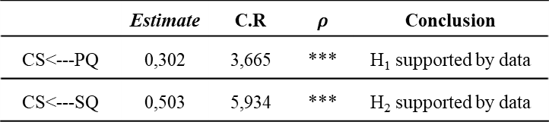
Table 6 Output Regression

Source: Results of data processing with AMOS 22.
Table 6 explains that the Product Quality variable has a positive effect on Customer Satisfaction because it has a positive value in the estimation result of 0.302, the value of Critical Ratio (3.665 > 1.96), and the value 𝜌*** is smaller than the required standard (𝜌 < 0.05). So it can be stated that product quality has a positive effect on customer satisfaction and is supported by data. While the Service Quality variable has a positive effect on customer satisfaction because it has a positive value in the estimated results of 0.503, the critical ratio value is (5.934 > 1.96), and the value 𝜌*** is smaller than the standard required (𝜌 < 0, 05). So it can be stated that service quality has a positive effect on customer satisfaction and is supported by data.
Discussion
All data analysis results show that all variables and indicators have been proven valid and reliable. The results of structural model testing show that 2 hypotheses are proven to have an effect and are supported by data. The results of the output regression table analysis state that product quality has a positive and significant effect on customer satisfaction. This proves that the product quality hypothesis produced by Waroeng Special Sambal "SS" in West Jakarta has a positive and significant effect on customer satisfaction. Consumers are satisfied with the products offered by Waroeng Sambal Special "SS" in West Jakarta, which in fact customers like spicy food according to Indonesian tongues, delicious food taste, and various menus offered. The results of this study are in accordance with research conducted (Maramis et al., 2018) that product quality partially has a positive and significant effect on consumer satisfaction.
Likewise, the results of the output regression table analysis state that the service quality hypothesis has a positive and significant effect on customer satisfaction. This proves the hypothesis that the quality of service provided by Waroeng Sambal Special "SS" has an influence on customer satisfaction. Customers are satisfied with the services provided such as friendly service, employees have good communication with customers. The results of this study are supported by research (H. Nofrianda, 2019), that service quality has a positive and significant effect on customer satisfaction, which means that the better the service quality, the higher the customer satisfaction.
This study only analyzes product quality, service quality and customer satisfaction. Many other factors can affect customer satisfaction, such as price, promotion, location and other factors, so that further researchers are expected to develop this research, increase the number of respondents, and examine other factors not examined in this study, such as price, promotion, location, and more. With the limitations of this research methodology related to the research design, sample, and this simple model can be added by researchers in future research.
5. CONCLUSIONS AND SUGGESTIONS
It can be concluded that product quality and service quality partially have a positive and significant effect on customer satisfaction at Waroeng Sambal Special "SS" West Jakarta.
The author's suggestion to Waroeng Sambal Special "SS" West Jakarta, is to improve the quality of products and services that are already good so that customer satisfaction is maintained, such as adding more attractive menus, saving packages, increasing employee friendliness to customers, maintaining cleanliness and comfort, and having better facilities such as clean toilets and more parking spaces. Meanwhile, suggestions for further researchers who want to examine product quality, service quality, and customer satisfaction are expected to be able to find sources and references to add research indicators so that research results can be better and more complete.

REFERENCES
L. Cucu Sumartini and D. Fajriany Ardining Tias, “Consumer Satisfaction Analysis to Increase Sales Volume of Coffee Shops at Twilight,” J. E-Bis, vol. 3, no. 2, pp. 111–118, 2019, doi: 10.37339/e-bis.v3i2.124.
[V. R. Herkaputra, “Analysis Of The Influence Of Product Quality And Service Quality On Consumer Satisfaction,” Anal. Biochem., vol. 11, no. 1, pp. 1–5, 2018, [Online]. Available: https://dspace.uii.ac.id/handle/123456789/5324.
Faradiba and S. R. T. Astuti, “Analysis Of The Influence Of Product Quality, Price, Location And Quality Of Service On Consumer’s Repurchasing Interest (Study On Warung ‘Bebek Gendut’ Semarang),” Diponegoro J. Manag., vol. 2, no. 3, pp. 1–11, 2013, [Online]. Available: http://ejournal-s1.undip.ac.id/index.php/djom.
S. Widjoyo, “The Influence of Service Quality and Product Quality on Customer Satisfaction and Consumer Loyalty of Happy Garden Restaurant Surabaya,” J. Manaj. Pemasar., vol. 2, no. 1, pp. 1–9, 2014, [Online]. Available: https://publication.petra.ac.id/index.php/manajemen-pemasaran/article/view/1404.
N. Siregar and F. Hakim, “Effect of Image, Product Quality and Price on Customer Loyalty at Kampoeng Deli Medan Restaurant,” J. Manaj. Tools, vol. 8, no. 2, pp. 87–96, 2017.
A. Fiaziah and P. Niken, “The Effect of Product Quality, Price, and Service Quality on Consumer Satisfaction Fast Food Restaurant Kfc Basuki Rahmat Surabaya,” J. Tata Boga, vol. 7, no. 2, pp. 178–187, 1970.
P. Kotler, Keller, and K. Lane, Marketing Management 13th edition vols 1 and 2, Ketigabela. PT Gelora Aksara Pratama, 2011.
M. Ibrahim and S. M. Thawil, “Influence Of Product Quality And Service Quality On Customer Satisfaction,” J. Ris. Manaj. dan Bisnis Fak. Ekon. UNIAT, vol. 4, no. 1, pp. 175–182, 2019, doi: 10.36226/jrmb.v4i1.251.
L. Trianah, D. Pranitasari, and S. Z. Marichs, “The Influence Of Product Quality And Service Quality On Customer Satisfaction And Customer Loyalty (Case Study On D’besto Mangun Jaya 2 Tambun Selatan Customers),” vol. 26, no. 01, pp. 105–122, 2017, [Online]. Available: https://www.ejournal.stei.ac.id/index.php/JEMI/article/view/201.
Mahira, P. Hadi, and H. Nastiti, “The Effect of Product Quality and Service Quality on Indihome Customer Satisfaction,” Pros. Konf. Ris. Nas. Ekon. Manajemen, dan Akunt., vol. 2, no. 1, pp. 1267–1283, 2021, [Online]. Available: https://conference.upnvj.ac.id/index.php/korelasi/article/view/1233.
I. Gunawan, N. Susanti, and E. P. Monique, “The Influence Of Prices On Customer Satisfaction On Delivery Services In Pt . Sap Express Branch Bengkulu The Influence Of Prices On Customer Satisfaction On Delivery Services In Pt. Sap Express Bengkulu Branch,” vol. 1, no. 4, pp. 220–227, 2020, [Online]. Available: https://penerbitadm.com/index.php/JURNALEMAK/article/view/38.
K. D. Yuangga and D. Sunarsi, “Analysis of the Effect of Product Quality and Service Quality on Customer Satisfaction (Case Study on Holland Bakery Pamulang),” J. Guru Kita, vol. 4, no. 3, pp. 51–58, 2020, [Online]. Available: https://jurnal.unimed.ac.id/2012/index.php/jgkp/article/view/19455.
M. F. Khasan, E. Rochaety, and D. A. Akbari, “The Influence of Product Quality and Service Quality on Consumer Satisfaction in Purchasing Curry Bend Blok M,” J. ilmu Manaj., vol. 6, no. 1, pp. 1–13, 2021, [Online]. Available: file:///C:/Users/62812/Downloads/10130-30246-1-PB.pdf.
M. A. Khairusy and R. Febriani, “The influence of product quality and service quality on customer satisfaction (Survey on customers of KFC Store Merdeka Bandung),” J. Manaj. dan kewirausahaan, pp. 1–12, 2020, [Online]. Available: http://ejournal.lppm-unbaja.ac.id/index.php/jmb/article/view/811.
N. Hartadi and N. E. Husda, “The Effect of Product Quality and Service Quality on Customer Satisfaction at PT Tanjung Uncang in Batam City,” J. EMBA J. Ris. Ekon. Manajemen, Bisnis dan Akunt., vol. 8, no. 3, pp. 34–43, 2020, doi: 10.35794/emba.v8i3.29412.
E. G. Asti and E. A. Ayuningtyas, “Effect of Service Quality, Product Quality and Price on Consumer Satisfaction (Effect of Service Quality, Product Quality and Price on Consumer Satisfaction),” J. Ekon. Manaj. bisnis, vol. 01, no. 01, pp. 1–14, 2020, [Online]. Available: http://journal.lppmpelitabangsa.id/index.php/ekomabis/article/view/2%0A.
R. R. Santoso and Khuzaini, “The Influence of Product Quality, Price, and Service Quality on Customer Satisfaction (Study on Lapis Kukus Pahlawan Surabaya at Rania Shop),” J. Ilmu dan Ris. Manaj., vol. 10, no. 2, pp. 1–16, 2021, [Online]. Available: http://jurnalmahasiswa.stiesia.ac.id/index.php/jirm/article/view/3908.
N. Ilmi and Khuzaini, “Effect of Product Quality, Price and Service Quality on Customer Satisfaction (Case Study on Customers of M22 Mini Cafe Surabaya),” Ilmu Dan Ris. Manaj., vol. 10, no. 6, pp. 1–15, 2021, [Online]. Available: http://jurnalmahasiswa.stiesia.ac.id/index.php/jirm/article/view/4071.
A. S. Aryamti and A. M. A. Suyanto, “Analysis of Product Quality, Service Quality and Brand Image on Customer Satisfaction at Beauty Clinics and Their Influence on Customer Loyalty,” E-Proceeding Manag., vol. 6, no. 1, pp. 131–138, 2019, [Online]. Available: https://openlibrarypublications.telkomuniversity.ac.id/index.php/management/article/view/8544.
I. Sasangka and R. Rusmayadi, “The Effect of Service Quality on Sales Volume at Mini Market Minamart’90 Bandung,” J. Ilm. Manajemen, Ekon. Akunt., vol. 2, no. 1, pp. 129–154, 2018, doi: 10.31955/mea.vol2.iss1.pp129-154.
P. E. Setyo, “The Effect of Product Quality and Price on Consumer Satisfaction ‘Best Autoworks,’” PERFORMA J. Manaj. dan Start-Up Bisnis, vol. 1, no. 6, pp. 755–764, 2017, [Online]. Available: https://journal.uc.ac.id/index.php/performa/article/view/404.
N. K. Malhotra, D. Nunan, and D. F. Birks, Marketing Research Fifth Edition An Applied Approach, Fifth Edit. London: Pearson Education Limited, 2016.
F. Fitriyana, Mustafid, and Suparti, “Analysis of the Effect of Service Quality and Product Quality on Customer Loyalty in Online Shops Using Structural Equation Modeling,” J. Gaussian, vol. 2, no. April, pp. 129–135, 2013, [Online]. Available: https://ejournal3.undip.ac.id/index.php/gaussian/article/view/2776.
A. Sudirman, M. Butarbutar, T. Sihol Nababan, and D. Puspitasari, “Customer Loyalty of Gojek Users Viewed From the Aspects of Service Quality and Consumer Satisfaction,” J. Ilm. Manaj., vol. 63, no. 1, pp. 63–73, 2020, [Online]. Available: http://www.ejournal.pelitaindonesia.ac.id/ojs32/index.php/PROCURATIO/index.
A. O. Siagian and H. Wijoyo, “The impact of service quality and product quality on consumer satisfaction PT. Brilliant Sinar Jaya,” Insight Manag. J., vol. 1, no. 3, pp. 106–114, 2021, [Online]. Available: https://journals.insightpub.org/index.php/imj.
F. S. Maramis, J. L. Sepang, and A. S. Soegoto, “The Effect of Product Quality, Price and Service Quality on Consumer Satisfaction At Pt. Manado Water,” J. EMBA J. Ris. Ekon. Manajemen, Bisnis dan Akunt., vol. 6, no. 3, pp. 1658–1667, 2018, doi: 10.35794/emba.v6i3.20411.
H. Nofrianda, “Analysis Of The Influence Of Product Quality, Service Quality And Price On Consumer Satisfaction (Case Study On Consumer Industry/Bakery Shops In Bengkulu City),” Manag. Insight J. Ilm. Manaj., vol. 13, no. 1, pp. 71–85, 2019, doi: 10.33369/insight.13.1.71-85.

