The Influence of Online Customer Reviews and Prices on Product Purchasing Decisions Fashion on the Shopee Marketplace in Bekasi
Ayu Wulandari ^{a,1}, Noviandari ^{b,2,*}, Jufri Sarlata ^{b,3}
ª Institut Ilmu Sosial dan Manajemen STIAMI, Jakarta, Indonesia
¹ ayyuwulandari9@gmail.com; ² andaritami17@gmail.com*; ³ jufrisarlata70@gmail.com
* corresponding author

ARTICLE INFO |  | ABSTRACT
Article history  Received  Revised  Accepted |  | This study aims to determine the effect of Online Customer reviews and Price on the decision to purchase Fashion products on the Shopee Marketplace in Bekasi. This study is quantitative research with the type of descriptive research. The data collection method used is a questionnaire. The population in this study is Shopee users who live in Bekasi with the number of unaccounted for. Sampling using Cochran's formula as many as 96 people with purposive sampling type of sampling. Data analysis techniques using multiple linear regression and using SPSS applications 25. Results of this study show that the influence of online customer reviews on purchase decisions by 40.6%, prices affect the purchase decisions by 62.8%. So that online customer reviews and prices influence significantly to the decision to purchase fashion products on the Shopee marketplace in Bekasi. Variable online customer review and price significant effect against simultaneous purchase decisions by 67.5%, of which 32.5% influenced by other variables not studied in this study.
Keywords
E WOM
Online Customer Review
Pricing
Purchasing Decisions

Introduction.
According to APJII data published by KataData (2022), internet users have increased significantly in Indonesia, making Indonesia the largest internet user in the world. In Indonesia, there are 210.03 million internet users in 2021-2022, according to a study by the Association of Indonesian Internet Service Organizations (APJII). Technology has a sociological role that has an impact on every human movement, behavior and activity. One of them is shopping. Currently, one of the shopping methods used in business transactions is shopping online through marketing or e-commerce.
According to statistics from Similar web (2022) Shopee is ranked among the sites -e-commerce top in Indonesia. Product categories available in e-commerce. The most popular Shopee categories are fashion. Findings from the Indonesian Political Indicators study (2022), show that fashion and clothing items are the most popular commodities purchased online.
Build customer trust in online marketplaces namely from online customer reviews which is on platforms. According to Putri & Wandebori (2016: 256) online customer reviews are experiences in using a product, specifications, results, advantages and disadvantages of a product that are felt by customers who have purchased the product. Customer reviews feature online, It is actually created so that customers who have purchased a product can share their experiences regarding the quality of the product or service from the seller as perceived by the buyer, so potential customers can use this customer review feature to collect information if they are interested in shopping for the product.
Price is another aspect that often influences customers' decisions to buy goods online. According to Kotler & Armstrong (2016: 324) price is the amount of money/ value that consumers exchange for a product or service and obtain benefits or ownership of a product or service. When product prices are adjusted to customer preferences, customers will easily choose to shop on line and make purchasing decisions.
Seeing the factors that influence purchasing decisions above according to experts, the researchers conducted previous research (pre-survey) to 30 respondents with 5 statements. These respondents are consumers who have purchased products fashion on marketplace Shopee. This pre-survey was carried out for 2 days from April 16 2023 to April 17 2023 via Google Forms. The results of the pre-survey carried out can be seen in the following table:
Table 1. Pre-Survey Data
No. | List of Statements | Yes | No
1. | I feel review on Shopee helps me determine  purchasing choices | 29 | 1
2. | More results review from other consumers, it will make it easier for me to make product purchasing decisions fashion on Shopee | 29 | 1
3. | I shop for products fashion via Shopee because the prices  are affordable | 27 | 3
4. | I chose to buy the product fashion on Shopee because  it is marketplace who is trustworthy | 27 | 3
5. | I find it easy to find products fashion on Shopee which  is affordable and quality | 26 | 4
Source: Data processed by the author in 2023
This shows the existence of a phenomenon, namely the product fashion become the most popular product on marketplace Shopee but based on results pre-survey which has been carried out at the beginning, there is still a gap in the answers from respondents. There are respondents who feel review or online customer reviews not very helpful in deciding on purchases and product prices fashion on Shopee it is not affordable and quality. This shows that there are still concerns and negative perceptions related to these aspects in the context of the experience of purchasing fashion products on Shopee.
Based on the background and phenomena that have been explained, researchers are interested in taking the title "Influence Online Customer Reviews and Price on Product Purchasing Decisions Fashion on Market places Shopee in Bekasi.” The aims of this research are:
- To find out and analyze influence Online Customer Reviews on Product Purchasing Decisions Fashion on Marketplaces Shopee in Bekasi
- To find out and analyze the influence of price on product purchasing decisions Fashion on Marketplaces Shopee in Bekasi
- To find out and analyze the influence Online Customer Reviews and Price simultaneously on Product Purchasing Decisions Fashion on Marketplaces Shopee in Bekasi

Literature Review

Online Customer Reviews
Putri & Wandebori (2016: 256) state that online customer reviews contain experience using the product, specifications, results, advantages and disadvantages of a product felt by customers who have purchased the product.
According to Ngadimen & Widyastuti (2021: 4) Online customer reviews is one of the words of mouth in online commerce, when customers use this information to make online purchases, customers can learn about the quality of the goods as well as the opinions of other customers.

Price
According to Kotler & Armstrong (2016: 324) price is the amount of money or value that consumers exchange for a product or service and obtain benefits or ownership of a product or service. According to Tjiptono (2015: 289) price is a flexible marketing component that can be easily changed and generates income for the business.
2.3 Purchase Decision
According to Kotler & Keller (2016: 198) purchasing decisions are the final decision made by consumers to buy certain products with certain considerations forming an intention to buy the most preferred brand. According to Gunarsih et al. (2021: 70) purchasing decisions are identifying all feasible solutions to a problem and evaluating options consistently and objectively, as well as determining profit and loss targets for each.

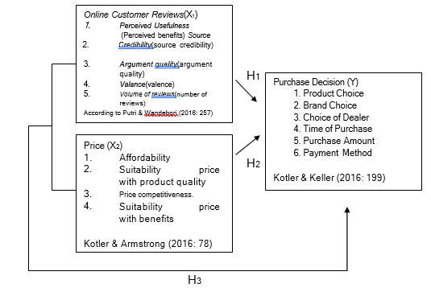
The theoretical framework is as follows :

Figure 1. Theoretical framework
Source: Data processed by the author in 2023

Method
In this research, researchers used quantitative approach with descriptive research type. This research uses 3 variables, namely Online Customer Review (X1), Price (X2) and Purchase Decision (Y). The data collection technique used was a questionnaire and used a Likert scale as a measurement scale. The population in this study is an uncountable number of Shopee users who live in Bekasi. Because the exact population size is not known, the sample calculation uses a formula Cochran with a total sample of 96 respondents.
In taking samples this research used non-probability sampling with type purposive sampling, The sample criteria selected as respondents are people living in Bekasi from all walks of life and ages who have used the Shopee application and have purchased products. Fashion via the Shopee application at least once. The data analysis technique uses multiple linear regression and uses the SPSS 25 application.
Based on the background and problem formulation above, the researcher formulated the following hypothesis :
H1: It is suspected that there is an influence of online customer reviews on purchasing decisions for fashion products on the Shopee marketplace in Bekasi
H2: It is suspected that there is an influence of price on purchasing decisions for fashion products on the Shopee marketplace in Bekasi
H3: It is suspected that there is an influence of online customer reviews and prices on purchasing decisions for fashion products on the Shopee marketplace in Bekasi

This research consists of 3 (three) variables, namely 2 (two) independent variables and 1 (one) dependent variable. The operational definition in this research is as follows:
According to Sugiyono (2019: 69) the independent variable or variable. The independent variables used in this research are Online Customer Reviews and Price.
According to Sugiyono (2019: 69) the dependent variable or variable Y or dependent variable is a variable that is influenced or produced as a result of the independent variable. The dependent variable used in this research is purchasing decisions
Table III. 1
Variable Operational Grid

Variable | Dimensions | Indicator | No. | Amount
Variable | Dimensions | Indicator | Items | Items
 |  | Perceiver Usefulness | 1, 2 | 2
Daughter & Wandebori | E WOM | Source credibility | 3, 4 | 2
 |  | Argument quality | 5, 6 | 2
257)
257) |  | Valance | 7, 8 | 2
 |  | Volume of reviews | 9, 10 | 2
 | Affordability | Affordable prices | 1
 | Price |  |  | 2
 | Price | Prices are relatively cheap | 2 | 2
 |  | price accordingly product quality | 3
 | Price |  |  | 2
Price | Price | price accordingly customer purchasing power | 4 | 2
Kotler & | Suitability | price accordingly benefits obtained | 5 | 2
Kotler & | Suitability | price accordingly the results offered |  | 2
(2016: 78) | Benefit | price accordingly the results offered | 6 | 2
 | Price Appropriate | product price can be compete in the market | 7
 | Price Appropriate |  |  | 2
 | Price Appropriate | cheaper price of the product the like |  | 2
 | or Power | cheaper price of the product the like | 8 | 2
 | Product selection | Diversity of variants product | 1
 |  | Product quality | 2 | 2
Decision | Brand choice | Brand Popularity | 3 | 2
Decision | Brand choice | Brand trust | 4 | 2
Purchase |  | Brand trust | 4
Purchase |  | Convenience get the product | 5
 | Choice of dealer | Convenience get the product | 5
Kotler & |  | Convenience get the product
Kotler & |  |  |  | 2
Kotler & |  | Product availability | 6
Keller |  | Product availability | 6
Keller |  | Buy products
(2016: |  | Buy products
(2016: |  | based on | 7
199) |  | based on | 7
199) | Time | time requirements
 | Time | time requirements |  | 2
 | purchase |  |  | 2
 | purchase | Timing |  | 2
 |  | purchase | 8
 |  | based on promotion

Results and Discussion

- Research Results
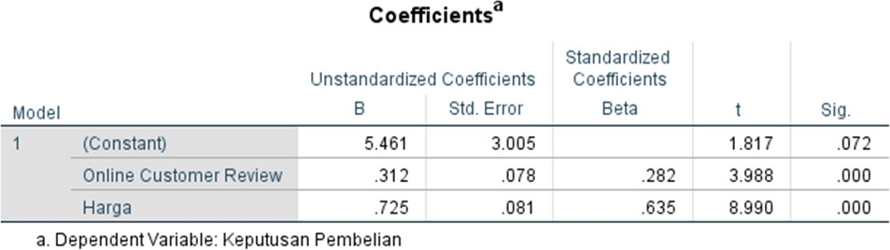
  - Results of Multiple Linear Regression Analysis
Figure 3. Multiple Linear Regression Coefficient Test Results
Source: SPSS Data Processing 25, 2023

Based on data analysis using SPSS 25, the following regression equation results were obtained: Y = 5.461 + 0.312X1+ 0.725X2
The regression equation above shows the relationship between the independent variable and the dependent variable partially, from this equation it can be concluded that:
      - The constant value (α) of 5.461 states that if the Online Customer Review and Price variables are constant (fixed), then the level of Purchase Decision that occurs is 5.461.
      - The online customer review regression coefficient value of 0.312 states that if online customer reviews (X1) increase by 1% then purchasing decisions (Y) will increase by 0.312 or 0.312% and vice versa, if online customer reviews decrease by 1% then purchasing decisions will decrease by 0.312 or 0.312%
      - The price regression coefficient value of 0.725 states that if the price (X2) increases by 1% then the purchasing decision (Y) will increase by 0.725 or 0.725% and vice versa, if the price decreases by 1% then the purchasing decision will decrease by 0.725 or 0.725%

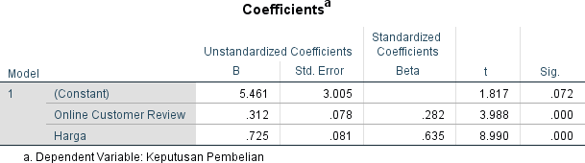
  - T Test Results (Partial)
Figure 4. T Test Results (Partial)
Source: SPSS Data Processing 25, 2023

From the data above it can be stated as follows:
- Based on the table above, it is known that the T test results are in variables Online Customer Reviews on purchasing decisions, it was found to be significant at
0.000 <0.05 and t count shows the results 3.988 > 1.985 t table, then it means there is a significant influence Online Customer Reviews on purchasing decisions. The first hypothesis is accepted.
- Furthermore, the results of the T test in the price variable on purchasing decisions were found to be significant at 0.000 < 0.05 and t count shows results of 8,990 > 1,985 t table, so it means there is a significant influence of price on purchasing decisions. The second hypothesis is accepted.

- F Test Results (Simultaneous)
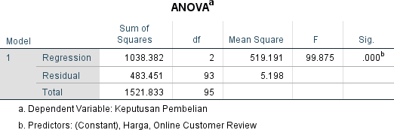

Figure 5. F Test Results (Simultaneous)
Source: SPSS Data Processing 25, 2023

Based on the results of the F test, the calculated F value was 99.875 > 3.094 F table and the significant value was 0.000 < 0.05. The conclusion means that simultaneously Online Customer Reviews (X1) and Price (X2) has a significant effect on purchasing decision, so the third hypothesis is accepted.

- Coefficient of Determination Test Results (R2)
- Variable Determination Coefficient Test Online Customer Reviews
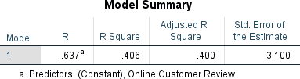
Figure 6. Variable Determination Coefficient Test ResultsOnline Customer Reviews
Source: SPSS Data Processing 25, 2023

In the table above it can be seen that the coefficient of determination (R Square) is 0.406. This means that the regression model obtained is able to explain that variable Online Customer Reviews(X1) can influence purchasing decisions by 40.6%.

- Test the Coefficient of Determination of Price Variables
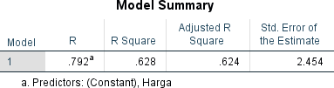

Figure 7. Test results for the coefficient of determination of the price variable
Source: SPSS Data Processing 25, 2023

In the table above it can be seen that the coefficient of determination (R Square) is 0.628. This means that the regression model obtained is able to explain that the Price variable (X2) can influence purchasing decisions by 62.8%.
- Variable Determination Coefficient TestOnline Customer Reviewsand Price
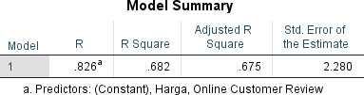
Figure 8. Coefficient of Determination Test Results (R2)
Source: SPSS Data Processing 25, 2023

In the picture above, it can be seen that the adjusted coefficient of determination (Adjusted R Square) is 0.675. This means that the regression model obtained is able to explain that the Online Customer Review variable (X1) and Price (X2) can influence purchasing decisions by 67.5%. Meanwhile, the remaining 32.5% is influenced by other unknown factors and is not included in this regression analysis.

Conclusion
    - Influence Online Customer Reviews Regarding Purchasing Decisions
Based on the results obtained, testing the T hypothesis shows that there is a positive influence and significance between Online Customer Reviews on Purchasing Decisions. The calculated t value > t table is (3.988 > 1.985 with significance (0.000 < 0.05). Thus, it shows that H0 rejected and H1 accepted, so there is a significant influence between Online Customer Reviews (X1) on Purchase Decisions (Y). Then it is known that the coefficient of determination or R Square is 0.406 or equal to 40.6%. Meanwhile, the remaining 59.4% was influenced by other variables not studied. Therefore, Online Customer Reviews positive and significant effect on product purchasing decisions Fashion on Marketplaces Shopee. H1 accepted.

Effect of Price on Purchasing Decisions
Based on the results obtained, testing the T hypothesis shows that there is a positive and significant influence between price on purchasing decisions.
The calculated t value > t table is (8.990 > 1.985 with significance (0.000 < 0.05). Thus, it shows that H0 rejected and H2 accepted, so there is a significant influence between Price (X2) on Purchase Decisions (Y). Then it is known that the coefficient of determination or R Square is 0.628 or equal to 62.8%. Meanwhile, the remaining 37.2% was influenced by other variables not studied. Thus, price has a positive and significant effect on product purchasing decisions Fashion on Marketplaces Shopee. H2 accepted.

    - Influence Online Customer Reviews and Price on Purchasing Decisions
Based on the results obtained, testing the T hypothesis shows that there is a positive influence and significance between Online Customer Reviews and Price on Purchasing Decisions. The calculated f value > f table is (99.875 > 3.094 with significance (0.000 < 0.05). Thus, it shows that H0 rejected and H3 accepted, so there is a significant influence between Online Customer Reviews(X1) and Price (X2) on Purchase Decisions (Y). Then it is known that the coefficient of determination or Adjusted R Square value is 0.675 or equal to 67.5%. Meanwhile, the remaining 32.5% is influenced by other variables not studied. Therefore,Online Customer Reviewsand Price simultaneously has a positive and significant effect on Product Purchasing Decisions Fashion on Marketplaces Shopee. H3accepted.

CONCLUSIONS AND SUGGESTIONS
Based on the results of analysis and hypothesis testing on Shopee users in Bekasi. So it can be concluded as follows:
  - Online customer reviews(X1) have a significant effect on product purchasing decisions (Y). fashion on marketplace Shopee in Bekasi was 40.6%.
  - Price (X2) has a significant effect on product purchasing decisions (Y). fashion on marketplace Shopee in Bekasi was 62.8%.
  - Online customer review(X1), and price (X2) together (simultaneously) have a significant effect on product purchasing decisions (Y). fashion on marketplace Shoppe in Bekasi was 67.5%.
Based on the research results above, researchers can provide the following suggestions:

Shopee should improve its online customer review function by encouraging buyers to post product reviews in a good way and by offering positive incentives.

Sellers should be honest in analyzing the quality of the goods they provide to maintain a balance between price and quality of fashion products.

It is best for Shopee or sellers to carry out strict quality control to ensure that the products sold meet established quality standards, collaborate with quality manufacturers and implement a simple product return policy and quality guarantee so that customers feel safe when shopping for fashion products on Shopee.

References
Artikel
Cindy Mutia Annur. (2022, September 22). Ini Situs E-Commerce dengan Pengunjung Terbanyak per Agustus 2022. Https://Databoks.Katadata.Co.Id/Datapublish/2022/09/20/Ini-Situs-e-Commerce- Dengan-Pengunjung-Terbanyak-per-Agustus-2022.
Dimas Bayu. (2022, June 10). APJII: Pengguna Internet Indonesia Tembus 210 Juta pada 2022. Https://Dataindonesia.Id/Digital/Detail/Apjii-Pengguna-Internet- Indonesia-Tembus-210-Juta-Pada-2022.
Raihan Hasya. (2022, May 2). Pakaian Jadi Barang yang Paling Sering Dibeli Masyarakat Indonesia Ketika Belanja Online. Https://Goodstats.Id/Article/Pakaian-

Jadi-Barang-Yang-Paling-Sering-Dibeli-Masyarakat-Indonesia-Ketika-Belanja- Online-WlAdP.
Buku
Kotler, P., & Armstrong, G. (2016). Principle of Marketing (15th ed.). Pearson Pretice Hall.
Kotler, P., & Keller, K. L. (2016). Marketing Managemen (15th ed.). Pearson Pretice Hall, Inc.
Tjiptono, F. (2014). Pemasaran Jasa – Prinsip, Penerapan, dan Penelitian. Andi Offset.

Jurnal
Gunarsih, C. M., Kalangi, J. A. F., & Tamengkel, L. F. (2021). Pengaruh harga terhadap keputusan pembelian konsumen di Toko Pelita Jaya Buyungon Amurang.
Productivity, 2(1), 69–72.
Ngadimen, A. N., & Widyastuti, E. (2021). Pengaruh social media marketing, online customer review, dan religiusitas terhadap keputusan pembelian konsumen shopee di masa pandemi Covid-19 dengan minat beli sebagai variabel intervening. Journal of Management and Digital Business, 1(2), 122–134.
Putri, L., & Wandebori, H. (2016). Factors influencing cosmetics purchase intention in indonesia based on online review. International Conference on Ethics of Business, Economics, and Social Science, 1, 255–263.

