JOKO WIDODO'S PUBLIC COMMUNICATION STYLE IN THE ELECTION OF PRESIDENT AND VICE PRESIDENT
Oman Sukmana ¹ , Euis Komalawati ^{2*} , Ika Yuliasari ³
^{1.3} Jayabaya University, Jakarta, Indonesia
2 STIAMI Institute of Social Sciences and Management, Jakarta, Indonesia
¹ oman.sukmana02@gmail.com*; ² komalawatieuis@gmail.com; ³
*corresponding author

Article history  Received  Revised  Accepted |  | The background of this study is situation The 2024 General Election began several years previously with the previous period coalition party bearer candidate president and vice presidential candidate, period after coalition party bearer candidate president and vice presidential candidate formed until approaching announcement candidate presidential and vice presidential candidates by party bearer. In the context that, Joko Widodo Still took office as President and communicated to the public with a diverse style of communication; the study aims to explain and analyze the Communication Style of Joko Widodo's Politics in the Election of President and Vice President in the 2024 General Election. Approach qualitative with paradigm constructivist used through method analysis Roland Barthes' Semiotics. The unit of analysis used is a Kompas TV YouTube video. The result shows Communication Style Joko Widodo's Politics in the Election President and Vice President in the 2024 General Election shows dynamics from before _ nomination President and Vice President, the future is approaching nomination President and Vice President to Commission General Election until the campaign period. In the early days of the General Election, Jokowi showed a Communication Style Controlling Style; in the future, Jokowi's public communication style Structuring Style during the campaign period in a way open, Jokowi pointed out style public communication Dynamic Style.
Keywords
Communication Style
Public Communication
Semiotics

INTRODUCTION
Democratic Party election for President and Vice President for 2024-2029 has _ started. Commission General Election (KPU) through KPU Regulation (PKPU) No. 3 of 2022 concerning Stages and Implementation Schedule Election 2024 has arrived to convey the schedule and stages of 2024 elections, including election president and if election president must be done in two rounds.
PKPU No. 3 of 2022 explained that the voice For election president collection process will be carried out on February 14, 2024. Collection process voice This will done simultaneously, okay For collection voice election president nor collection voice For election legislative. The calculation process sound and recapitulation results voice will done afterwards until March 20, 2024.
If the election president must take place in two rounds, then the voting process for the voice election 2024 president will carried out on June 26, 2024, after previously the campaign process, and the cooling off period will be carried out takes place from June 2 2024, to June 25 2024. After collection, the voice will calculate sound and recapitulation results collection voice. The second one will occur from June 26 2024, to July 20 2024. If not, there is trouble transverse. Whatever the pronunciation of the oath/promise of the President and vice president for the period 2024-2029 will be conducted on October 20, 2024. https://infopemilu.kpu.go.id/Pemilu/Peserta_pemilu
Commission election general Finally, set three partners for the candidate president and future vice presidential candidate in 2024. They are partner Anies Baswedan – Muhaimin Iskandar, Prabowo Subianto – Gibran Rakabuming Raka and Ganjar Pranowo – M. Mahfud MD. In the draw number message on Tuesday (14/11/2023), couple Anies Baswedan – and Muhaimin Iskandar got the number sequence 1. Meanwhile, the Prabowo Subianto – Gibran Rakabuming Raka pair won number order two, and partner Reward Pranowo and Mahfud MD obtained number sequence 3.
The journey appearance of three pairs of presidential and vice presidential candidates for 2024 Alone coloured lots of drama. Starting from political lobbies that failed, broke up shared parties, split shared friendships, drama " betrayal " to the emergence of " horse black," i.e. the candidates who arrived _ and arrived.
One of the people mentioned plays a vital role in the appearance of three pairs of candidates, President and Vice President 2024 – 2029, is Joko Widodo, who is familiar with Jokowi. As President Republic of Indonesia's 7th term of office will end in 2024, because it has been two periods of office, Jokowi considered the interests of the President elected in the next period can continue progress and programs that have been carried out did it.
Jokowi is interested in the contestation process of the presidential election. This showed through girls what Jokowi started doing before _ he determined partner presidential and vice presidential candidates until the contestation of presidential and vice presidential candidates took place. Girls seen including through _ through style Jokowi 's communication was good in gestures or current verbal communication do interaction with party political nor with will candidate President and vice president.
According to Norton (in Allen et al. 2006), style of communication is defined as a method by which somebody interacts, both verbally and non-verbally, to give a sign that the true Meaning must understood or understood as well as To get a response or response specific in certain situations too.
Meanwhile, Sendjaja (1996) said style communication is behaviour communication carried out by somebody in a purposeful organization _ to get feedback from others towards message organizational delivery.
Suranto (2011) stated that style communication is a set behaviour between specialized personalities _ used in something situation specific. Each communication style consists of a bunch of behaviour communication used _ To get a response or response in certain situations, too. The suitability of One style of communication used _ depends on the intent of the sender and hope from the receiver.
The situation faced by a person usually influences their communication style. In general, people will use style different communication _ in different situations, for example, when currently happy, sad, angry, interested, or bored.
In doing this, the researcher will use social media, specifically the Kompas TV YouTube channel, as a reference for obtaining data for analysis. The reason for selecting YouTube channels to obtain data is because Its advantages and characteristics make it easy for writers to study. Social media has the advantage of YouTube channels: it can reach all places globally quickly and easily, making it possible for researchers to study without having to go directly or meet directly with Jokowi. The researcher Can utilize video footage showing the activity and style of communication of Joko Widodo's politics in the election of President and vice president in 2024, which was uploaded to a YouTube channel as data to make time more effective and efficient. Apart from that, the character of the social media nature of YouTube _ archiving (storage) makes it easy for researchers to download _ video footage anytime and anywhere and play videos directly over and over again during the video—no deletion from the YouTube channel.
Kompas TV was selected as the media reference researcher for the material study because this media is positioned as an independent and trusted medium. The public knows Kompas TV as a media that is not impartial and credible, so content media content produced, including those uploaded on the Kompas TV YouTube channel, can trusted.
See Lots related elements _ in the study this; writer limits that study style Jokowi's communication in election President and vice president This carried out in the period before the formation of coalition party before exists partner presidential and vice presidential candidates, emergence partner presidential and vice presidential candidates until contestation presidential and vice presidential candidates taking place in the period May 2023 to January 2024.
The communication styles studied are also limited to styles communication verbally good _ in matter election language and word choice and non-verbal (body language) on the message kinesics (body movement), proxemics (distance and space) as well message paralinguistics (tone of speech) which is later linked with theory style communication. Likewise, inside _ matter meaning captured _ from communication politics style that Jokowi practices in influence the selection process general in 2024.

According to Norton (Allen et al., 2006), the shared communication style becomes: (1) Dominant, communicator dominant in interaction. People like This tend to want to control the conversation ; (2) Dramatic, deep matter communication tends to overuse, use containing things _ like allegory, metaphor, story, fantasy, and game voice ; (3) Animated Expressive, colour in communication, like contact eyes, expression face, gesture and body movements ; (4) Open, communicator behave open, no There is confidential so that trust arises _ self and form two- way communication ; (5) Argumentative, communicator tend Like argumentative and aggressive in argue ; (6) Relaxed, communicator capable behave positive and mutual support towards others; (7) Attentive, communicator interact with other people with become active, empathetic and sensitive listener ; (8) Impression Leaving, ability a communicator in form impression on the listener. The communicator behaves in a friendly, suave, and polite moment currently conveying a message to the recipient message ; (9) Friendly, the style used by the communicator to build relation parallel appropriately friendship with friendliness; and (10) Precise, the right style Where the communicator requests to talk about something precise and accurate content _ in communication verbal.
Temporarily, Edward T. Hall shares a style of communication that is attached to the self somebody in two contexts, high communication context (high context) and low communication context (low context). The setting's different culture influences each style of communication. Low context culture is the nature of communication straight away, what it is, straightforward without convoluted. In context communication, these are the perpetrator's No Like Chit Chat. In general, the communication context is aimed at patterns of oral communication, direct conversation, and send-oriented marks. The main thing is in the communication context.
Meanwhile, high communication context or High Context Culture (HCC) tends to use explicit words in explaining messages between _ them, especially the spoken word. Most messages are delivered with non-verbal symbols. In two contexts, style communication earlier, there are two dimensions viz explicit and implicit, which describes How somebody discloses intention through a message explicit or direct message. What is meant is that with style communication, explicit is the one who speaks directly and states feelings, intentions, desires, or to the point. Meanwhile, implicit style communication is the one that speaks orally with hidden intention or meaning.
Toomey describes the face as an image of self shown _ in the conversation with others. According to Goffman, face is retained, lost, or _ strengthened. According to Toomey, the desire for advancement is a universal desire. Diversity culture influences methods related and how they are displayed.
In describing this draft, Toomey distinguishes between face concern and face need. Face concern is interest in maintaining people's or others' faces in advance. At the same time, Face needs are the desire for association or no association with other people.
In its development, Brown and Levinson added the Politeness theory (Brown & Levinson), where people use politeness strategies based on their perceived threat. Both develop a cheerful face, a desire to be liked and admired by essential people, and an opposing face, which refers to a desire for autonomy and not restraint.
In their study, Brown and Levinson explained that draft facework is actions taken to face desire will advance someone and other people. Several Types of facework include Tact facework, solidarity facework, and approbation facework.
Toomey & Chung added that our verbal and non-verbal strategies are used to maintain, sustain, and improve the image of self social us, attack or maintain (or ' rescue ') the image of other people's social.
With a given limitation study, this study will become more focused, specific, and more profound concerning the style of communication of Jokowi's politics in the election of President and vice president in 2024.
In research about Communication Style Joko Widodo's Politics in the Election President and Vice President with approach Analysis Roland Barthes ' Semiotics in the 2024 General Election writer browse studies previous as part of the state of the art study that will be developed.
Studies _ previous the writer tries to analyze and summarize twenty _ studies sourced from primary references, i.e. Scientific journal, as well as several study, theses, and dissertations.
Narrative Communication style, specifically about leadership has done by some researchers previously, including studies _ about style of Bambang Soesatyo's communication (Martianto, 2021); Agus et al. (Rafiq et al., 2022); Tommy Soeharto (Krisna, 2021); Basuki et al. (Rahmah, 2018); Nadiem Makarim (Sembodo et al., 2022); Reward Pranowo (Pratiwi, 2023); as well as several style communication figures abroad such as Boko Haram Leadership Style (Abua, 2021) and President Banda in the Malawian Newspaper (Chikaipa, 2019 ). Style study communication uses diverse approach theories, including the Communicator Style Measure of Robert Norton consisting of Impression Leaving, Open, Friendly, Relaxed, Dramatic, and Attentive; style Jude Burgoon's verbal and nonverbal communication; style communication Traits Theory; style communications Stewards L. Tubbs and Sylvia Moss; style communication Low Context Culture (LCC) and High Context Culture.
This study also explains the communication style using Tubbs & Moss's approach, which became unique in the study. The writer observes that the background behind culture also comes into play with the underlying style of Joko Widodo's leadership. Therefore, the writer synthesized Tubbs and Moss's Communication Style theory and approach to intercultural communication through the Face Negotiation Theory analysis from Stella Ting Toomey and Levinson: this draft,fthisodraft'sd politeness theory, a powerful background style Joko Wstyles for communications.
From various study of communication styles, the usage method semiotics also underlies the researcher's conclusion. Semiotic studies used _ diverse namely Saussure, Charles Sanders Pierce, John Fiske, Roland Bathes, Cognitive semiotics, and multimodal critical discourse analysis. In researching this, the writer especially unpacks discourse style Joko Widodo's communication with Roland Bathes' revealing approach meaning in several stages denotation, connotation down to myth style communication. Therefore, the Face Negotiation Theory approach with facework analysis will be very relevant for unpacking the myth style of Joko Widodo's leadership.
Leadership style studies previously see the text as a discourse that emerged both in mass media, social media, and advertising politics, as well as in daily context. This study emphasizes discourse _ in the form of a video on YouTube Kompas TV. Kompas TV documentation is a video broadcast on Kompas TV as mass media. Therefore discourse. This media convergence is present in mass media and extends to social media, particularly YouTube.
Based on previous studies and the author's state-of-the-art art to develop it, then several expected novelty _ from the study, including This study browse style communication a developing leader _ dynamic from time to time. In some previous studies, researchers only explained the style of communication of a leader in one context. Time is temporary. In a study, researchers try to disclose dynamic changes in the communication style by social, political, and cultural contexts. For this matter, the author _ will take the unit of analysis in a way coherent from the time before nomination, after determination until the moment of the campaign Election in 2024. These two studies develop research on the previous use of draft-style communication in context communication organizations. In researching this, the writer tries to synthesize the two approaches, i.e., communication style in context communication organization and setting behind culture through face negotiation theory in context communication intercultural. Elaboration second approach: This Communication Style analysis is unique, yet _ was carried out in previous research.
Based on reality, the writer is interested in analyzing Joko Widodo 's political communication style in the election of President and Vice President in the 2024 general election. The title of this research is "Joko Widodo's Public Communication Style in the Election of President and Vice President with formulation problem namely: (1) What is the Communication Style Joko Widodo's Politics in the Election President and Vice President in the 2024 General Election?; and (2) What Meaning Denotation, Connotation and Myths Contained in Communication Style _ Joko Widodo's Politics in the Election President and Vice President in the 2024 General Election?

METHODS

In this research, researchers use paradigm constructivism as a paradigm study. Constructivism is looking at reality socially; it is not a natural reality but formed from construction results.
Constructivism delivers humans on both levels; however, these two levels explain _ that that is the real Meaning of paradigm. First, after the Kompas TV YouTube program shows about style related to Joko Widodo's communications Election President, men own multiple views and different meanings _ _ for each person. The second level, besides man, views impressions in impressions YouTube Kompas TV, humans explain meaning from every individual depending on their experience, every problem _ faced, factors environment, education, etc. information support received man Alone in a way individual. This is Framework Research, which is the author's research design by the objective study :

Chart 1. Research Framework

Data collection techniques:
Kompas TV Youtube Show Documentation on Joko Widodo's Communication Style Discourse on the Presidential Election
Documentation Historical articles and notes related to social context
Interview with editor of Kompas TV
Literature Study
Observations on the social context in the 2024 elections

Kompas TV Youtube Show Documentation on Joko Widodo's Communication Style Discourse on the Presidential Election
Signs about Joko Widodo's Communication Style related to image and ideas illustrated through: language (dialogue), appearance and behavior

Roland Barthes' Semiotic Analysis, on Joko Widodo's Communication Style sign
Signified
Signifier
Myth

Analysis and Research Results (Steward L.Tubbs and Sylvia Moss)
Communication Style
State of the art

Interpretation of Research Results
Analysis of the socio-political context related to the 2024 elections

Theory Discussion
Researchers try to discuss the theories and concepts used in this study, especially on the style of political communication through the media

Conclusion
Researchers formulate conclusions in accordance with the objectives of the study

Recommendations
Researchers provide recommendations related to the significance of research based on the results and interpretation of the study

The objects of Communication Style research Joko Widodo's Politics in the Election President and Vice president from Kompas TV Youtube video show about discourse on Joko Widodo's Communication Style in Election 2024. Election Kompas TV's YouTube video about Joko Widodo 's Communication Style was taken based on the previous context _ the determination of the partner candidate President and Vice President, the period after determination by the KPU, and during the campaign period for the 2024 presidential election.

Table 1. Units of Analysis

Context | Title | Videos
Before coalition party bearer presidential and vice presidential candidates formed | Selfie Moment of Ganjar with Jokowi and Prabowo (March 9, 2023) | 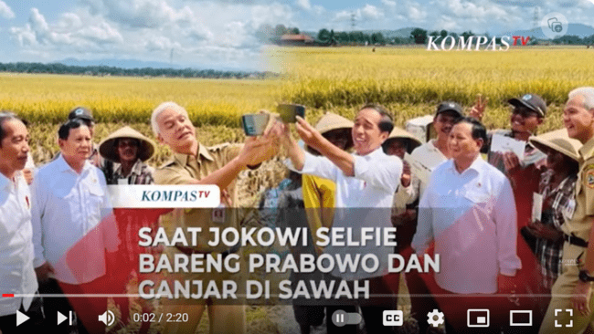
After coalition party bearer presidential and vicepresidential candidates forming and approaching announcement presidential and vice presidential candidates by party bearer | Jokowi's response to the Prabowo – Gibran duet plan (4 May 2023) | 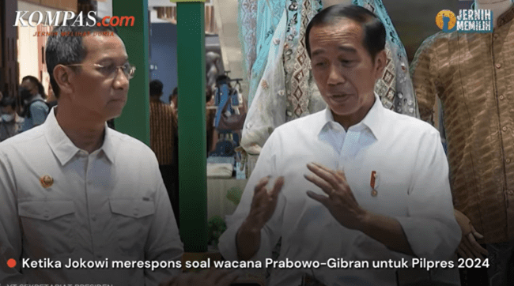
Campaign period 2024 presidential election | Joko wi's comments regarding Debate Presidential candidate Third: Personal attacks, lack of education (January 8, 2024) | 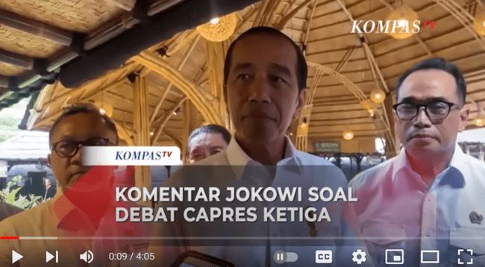

The data of this study was sourced from Kompas TV's YouTube video document, interviews, and studies' bibliography. Researchers also choose data collection is carried out in a way directly through an interview process with informants, also supported by secondary data from literature and supporting data sources, where each other _ supports and complements the data conducted by researchers related to Joko Widodo's Communication Style in Election President and vice president in 2024.
To reveal Joko Widodo's Communication Style in the 2024 Election, the researcher uses analysis text, i.e. semiotics Roland Barthes (1915-1980). Analysis semiotics of Roland Barthes emphasizes meaning from something system sign through system meaning level first ( first order ) or regular called with denotation, next to system meaning level second (second order ) is called connotation and the last form disclosure myth.
The analysis of this study is done in two stages. First is denotation stage, i.e. research in this stages production meaning with see Signs of Joko Widodo's Communication Style in the 2024 Election via Related Kompas TV YouTube video shows visualized images and ideas _ through sign language (dialogue), appearance and behavior that carries sign of communication style. The sign is interpreted in a denotative way. The second stage is connotation, i.e., where the researcher explores the Meaning hidden behind the sign related to the context, social and political moments, and text produced. Furthermore, the meaning connotation in stage two stage _ next is meaning denotation. In the next stage, the researcher links meaning to myths and ideology. Through two-stage Meaning, This researcher reveals Joko Widodo's Communication Style in the 2024 Election as depicted in the existing picture in mind (map conceptual) and language.

RESULTS AND DISCUSSION
The study of Joko Widodo 's public communication style analyzes videos on YouTube Kompas TV that narrate Kompas TV reporting. Analysis related to three context times: Before coalition party bearer, presidential and vice presidential candidates formed with title "Moment to Reward Selfies with Jokowi and Prabowo" on March 9, 2023. The second context is after coalition party bearer presidential and vicepresidential candidates forming and approaching announcement presidential and vicepresidential candidates by party bearer with the title " Jokowi's response to Prabowo - Gibran duet plans " dated May 4, 2023. Moreover, third context is campaign 2024 presidential election titled " Jokowi's comments regarding Debate Presidential candidate Third: Personal Attacks, Lack of Education ", dated January 8, 2024.
The Analysis of Semiotics carried out in the first video as in table 2 below show: analysis first stage that is denotation stage show the video with background of fields that turn yellow in season harvest, President walking on the rice fields with Prabowo and Ganjar with cheerful. All of them show familiarity while laughing and taking pictures with a background of moderate farmers _ harvest. The President and Prabowo were accompanied by staff wearing white clothes, whereas Reward used uniform official government-colored chocolate. In the second analysis stage, i.e. connotation, the Atmosphere harvest Raya with yellow rice fields and happy farmers _ shows a successful harvest, success in a way economy in the Central Java region. President shows closeness and familiarity with Prabowo and Ganjar currently. That crowd is depicted as the candidate president next. In interview visits, the Work President shows partiality to the government throughout the party, neither the good farmer nor the public related to the harvest kingdom. Meanwhile, the analysis stage is the meaning denotation stage. Two later researchers try meaning shortly Election President show a style of communication, where in interaction, He controls situations capable of communication positioning Prabowo and Ganjar as will candidate future leaders through influence.
Table 2. Analysis Video Semiotics 1
Selfie Moment Ganjar with Jokowi and Prabowo (March 9, 2023)
FIRST LEVEL ANALYSIS
DIALOGUE/SOUND/TEXT | VISUAL | SIGNIFIED
Jokowi: "Many and new provinces harvest kingdom. That was why I asked direct farmers _ that no way the price of 4200 was indeed too low, so the government This currently calculated and later quickly announced by the food agency price it's okay it should How many Because we have inside cost calculations for every component, production of rice. This Already visible everything Good about rent land, fertilizer, seeds, and others No meet. Later, the food agency will announce that We expect the price of grain from the farmer. That is reasonable, the price of rice at the trader is reasonable, and the price of rice by the Community is in a reasonable position. Everything gets benefits and advantages from the calculation. That ". | 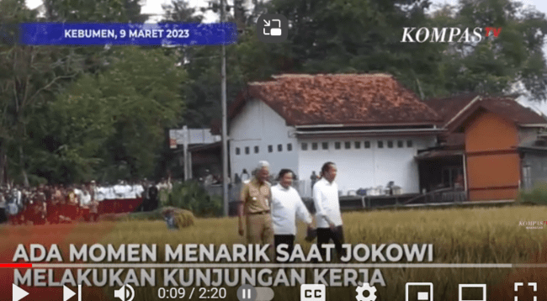  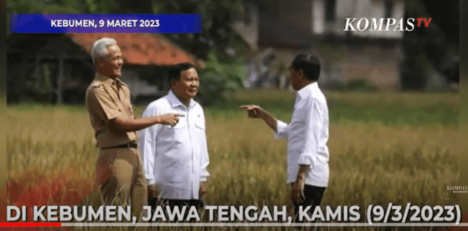  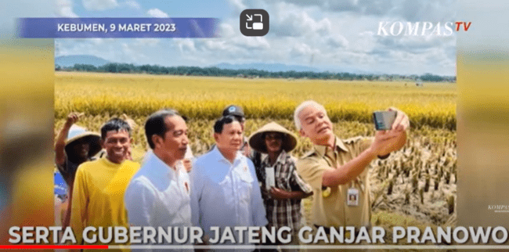  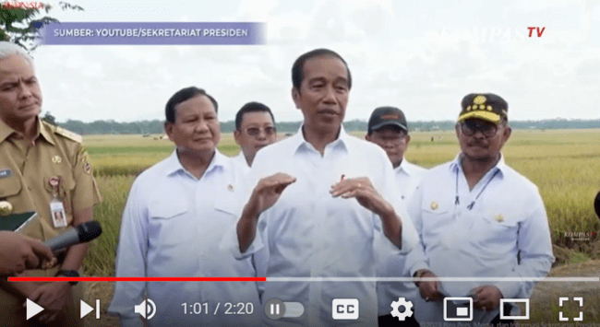
Signifier (1) | Signified (1)= Signifier (2) | Signified (2)
With a background of rice fields that turn yellow in the harvest season, the President walks on the rice fields with Prabowo and Ganjar in a cheerful atmosphere. All of them show familiarity while laughing and taking pictures with a background of moderate farmers _ harvest. The President and Prabowo were accompanied by staff wearing white clothes, whereas Reward used uniform official government-colored chocolate. | Atmosphere harvest with yellow rice fields and happy farmers show successful harvest, success in a way economy in the Central Java region.  President shows closeness and familiarity with Prabowo and Ganjar currently. That crowd is depicted as the candidate president next.  In interview visits, the Work President shows partiality to the government throughout _ the party, neither the Good farmer nor the public related to the harvest kingdom. | Shortly after the Election, the President showed a style of communication where, in interaction, He controls situations capable of communication _ positioning Prabowo and Ganjar as the candidate's future leaders _ through influence. The President also pointed out their Relaxed communication style, where He is capable of behaving positively and mutual support towards other people.

The analysis of Semiotics is carried out in the second video presented in Table 3 below. This shows the analysis first stage, that is, stage denotation. The video has several scenes, beginning with meeting the leader party coalition led by Prabowo with the President. In the next scene, Gibran is visualized wearing a mask. In the next scene, the President answers the question of the journalist accompanied by the Acting Governor of DKI Jakarta Heru. In answering questions, presidents tend to Relax while occasionally laughing. In the analysis stage, the second, i.e. connotation, indicates the meeting that the President initiated with leaders of the coalition led by Prabowo showed support for the coalition party. Deep sitting position meeting the show domination The President directs the leaders party coalition about discourse future leadership. In the interview session with the journalist, the President behaved Relax with the use of body language and gestures as well as verbal expression of denial of the possibility that his son namely, Gibran, would be vice presidential candidate because of various reasons, so at the end interview verbally, the President said impossibility the with the statement "which is logical ...". In contrast, the analysis is the denotation stage. Later, the researcher tried meaning that shortly after the nomination of the President and Vice President, President Jokowi pointed out that the style of effortful communication builds impact on society. The impression shows attitude and position strong as one of the vital parties in determining future leadership. Try Impression Leaving He lifts with his strength to gather leader party coalition. Besides, he uses a style of communication that precisely answers journalists and discusses precise and accurate content communication orally while disclosing reasons for why his son was chosen as the vice presidential candidate.

Table 3. Analysis Semiotics Video 2
Jokowi's response to the Prabowo – Gibran duet plan (4 May 2023)
FIRST LEVEL ANALYSIS
DIALOGUE/SOUND/TEXT | VISUAL | SIGNIFIED
W: “ ….. ”  Jokowi: "Yes, of course. No invited … (Jokowi laughs )… Nasdem, yes, we must talk about what exists. Well, that is, then own coalition Alone. Ad this combined yesterday's party gathering. That also builds other political cooperation. This should be right and has a big strategy. Yes, it is time to be here and know the strategy right it should be No like That. In politics, that's the normal course, and that is official public at a time, so it is normal if I speak politics. Yes, you can. Yes, I am speaking about something related to service. The public can do it too, and indeed, That tasks a president, only of course, if Already Later There is KPU decision, I That …"  W: "... "  A:" Yang discussed Lots once, 3 hours, a lot once, anything, everything talked about, everyone discussed No That just, everything related discussions _ mainly related _ with country politics to front will like what, the challenges of this country what, everything and that need leadership national with solid leadership that is trusted by the people, trusted by the international community, trusted by investors, trusted by...(Jokowi opened second his hand to the front )".  W: "... Mr Prabowo and Mr Gibran have an arranged marriage ...:  J: "That is all I heard too ... (Jokowi laughs )... first age, the second one is only two years. Just So What mayor, which is logical, do it ." | 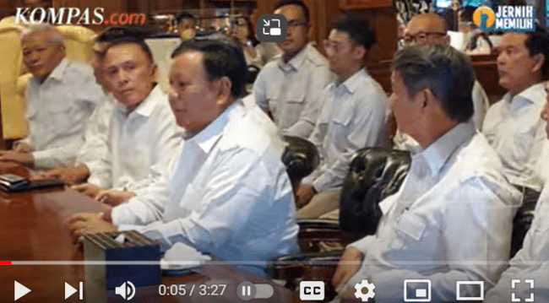  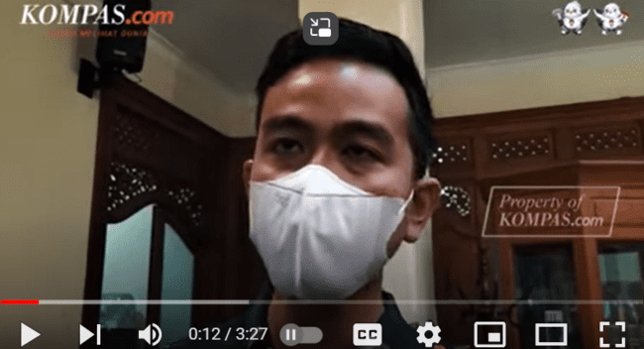  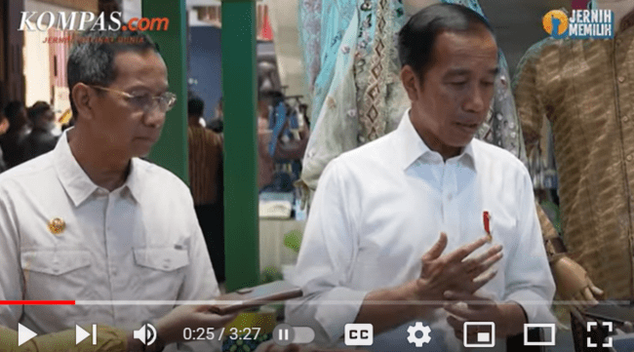  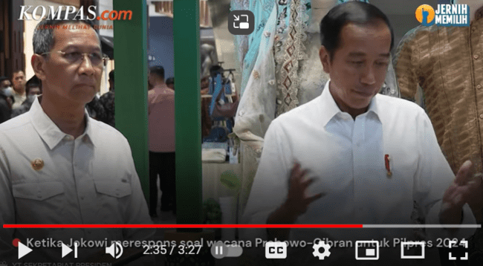  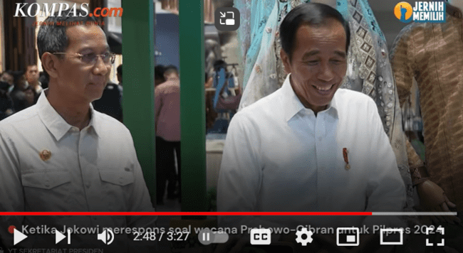
 | Signified (1)= Signifier (2) | Signified (2)
  Signifier (1) | Signified (1)= Signifier (2) | Signified (2)
The video has several scenes, beginning with meeting the leader party coalition led by Prabowo with the President. In the next scene, Gibran is visualized wearing a mask. In the next scene, the President answers the journalist's question accompanied by the Acting _ Governor of DKI Jakarta Heru. In answering questions, presidents tend to Relax while occasionally laugh | The President initiated the meeting with leaders of the coalition led by Prabowo, who supported the coalition party. Deep sitting position meeting the show domination The President directs the leaders party coalition about discourse future leadership. In the interview with the journalist, the President behaved relaxedly with the use of body language and gestures as well as verbal expressions of denial of the possibility that his son, namely Gibran, would be a vice presidential candidate. For various reasons, at the end of the interview, the President said, "Which is logical ..." | Shortly after the nomination of President and Vice President, President Jokowi pointed out the style of effortful communication to build an impact on society. The impression shows attitude and position strong as one of the vital parties in determining future leadership. Try Impression Leaving He lifts with his strength to gather leader party coalition. Besides that, he uses a style of communication precisely answering journalists and discusses precise and accurate content _ communication while disclosing reasons for the impossibility of his son being chosen as the vice presidential candidate

Furthermore, the analysis of Semiotics carried out in the third video is described in Table 4 below. This shows the first stage is, the denotation stage described in the video. There are several scenes. The first scene President was accompanied by two ministers, Zulkifli Hasan, Chairman of the Party Coalition that supports President and Vice President Prabowo and Gibran, and Budi Karya, Minister of Transportation. The President answered questions from journalists about his opinion post-Presidential Candidate Debate Commission Third General Election. The next scene displays a video clip of the debate, starting with the video of Prabowo, Ganjar, and Annis Baswedan. In the second stage analysis, i.e., connotation, indicating in a way meaning the President's video response question journalist shows partiality between the candidate President and vice president number order 2 Prabowo and Gibran. This means that in a way implied and visible in the session interview, the President is accompanied by one Chairman of the Party Coalition supporter candidate, President number 2.
Meanwhile, in a way That appears in response, the President conveyed verbal disappointment because, according to him, the debate candidate President tends to corner candidate number 2, Prabowo. The following analysis shows that the public communication style used by Joko Widodo is an excellent verbal and nonverbal open communication style. He behaved openly and literally on the bright side with the candidate, President number 2 Prabowo, and showed no confidentiality regarding his support. Besides the style of open communication, Joko Widodo also uses the style of Argumentative communication, that he tends to argue related matters his support in an aggressive argument defense of the attitude of candidate President Prabowo in the Presidential Candidate Debate.

Table 4. Analysis Video Semiotics 3
Joko wi's comments regarding Debate Presidential candidate Third: Personal attacks, lack of education
(January 8, 2024)

FIRST LEVEL ANALYSIS
DIALOGUE/SOUND/TEXT | VISUAL | SIGNIFIED
Journalist: " Related sir with debate last night, e…, ………… …. if you like What?  Jokowi: "The first, of course, I see substance from his vision somewhat No visible _ precisely each other honest actual _ No anything origin policy, origin policy, origin assaulted vision _ No anything. However, if people are already attacking personal persons who are not, there is a connection with the context debate earlier evening about what connection international, regarding geopolitics, considering defense and others; I think there is not enough education, less education the people who watch. I think many are disappointed, so the debate needs to be formatted more Well. Some signs live, each other attack No anything But policies, policy, vision are being attacked No For each other drop with personal motives. I think No good and educational ".  W: “ Some narrative discussed ... "  A: "Yes, if us, us this is in government in nation and state That everything referring to the law right, of course, allow until maximum 60%, and we should too see that he….. debt We compared with gdb That still in the condition be good and be safe, still under 40, right? Remember, in big countries there already are 260, some are 220 per cent, some are in neighbours us, no I call there are 120 countries, some 66; I think what is the most crucial debt That must used For productive interests that can _ give a return to the country so that the country later Can pay it with it too increase in our GDP from year to year, period to period. I think the most important thing ".  W: "... "  A:" Yang related with defense, related with state security, which is related to defense equipment That Anyone can _ open, But many indeed _ must. We keep it a secret Because concerning a big state strategy, no Can everything opened like a grocery shop, no can, no Can ". | 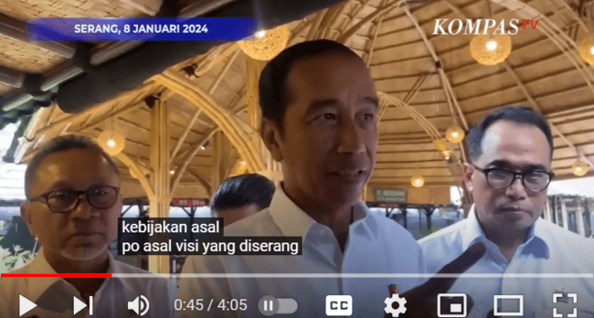  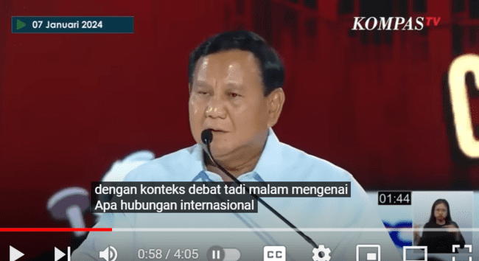  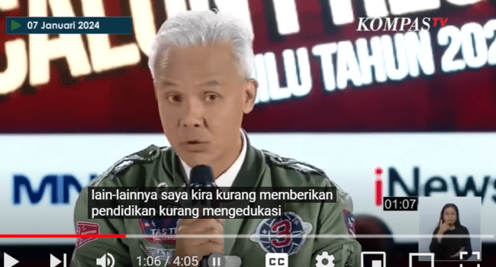  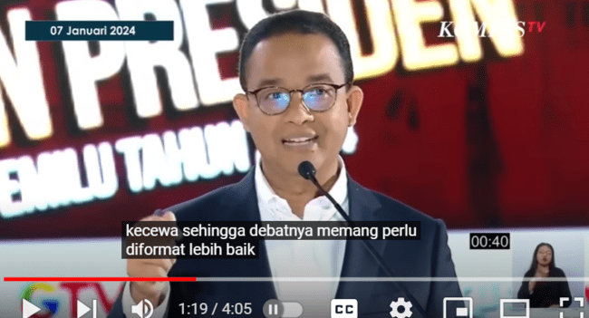  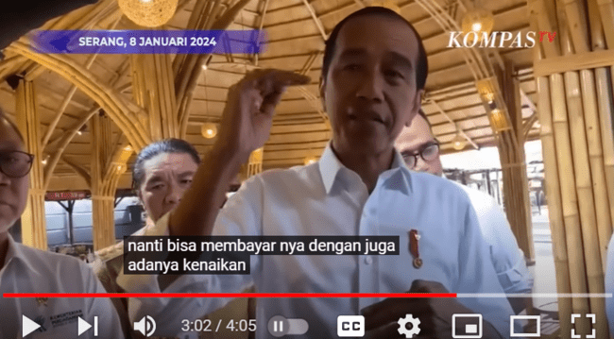
 | Signified (1)= Signifier (2) | Signified (2)
  Signifier (1) | Signified (1)= Signifier (2) | Signified (2)
In the video, there are several scenes. The first, President was accompanied by two ministers, Zulkifli Hasan, Chairman of the Party Coalition that supports President and Vice President Prabowo and Gibran, and Budi Karya, Minister of Transportation. The President answered questions from journalists about his opinion post-Presidential Candidate Debate Commission Third General Election. The next scene is a video clip of the debate, starting with the video of Prabowo, Ganjar, and Annis Baswedan. | By meaning the President's video response questions, the journalist shows partiality to the pair candidate President and Vice President number order 2 Prabowo and Gibran. This means that in a way implied and visible in the session interview, the President is accompanied by one Chairman of the Party Coalition supporter candidate, President number 2. Meanwhile, in a way That appears in response, the President conveyed verbal disappointment Because, according to him, the debate candidate President tends to corner candidate number 2, Prabowo. | The public communication style used by Joko Widodo is good verbally and nonverbally, showing an open Communication Style. He behaves openly, sides with candidate President #2 Prabowo, and shows no confidential support. Besides the style of open communication, Joko Widodo also uses the style of Argumentative communication, that he tends to argue related matters _ with his support in an aggressive argument defense of the attitude of candidate President Prabowo in the Presidential Candidate Debate.

Joko Widodo 's public communication style in the 2024 General Election to the moment campaign shows the dynamics of Public Communication. Joko Widodo does not play one style of public communication but by context, time, and situation. In the early days ahead of the General Election, Jokowi Communication Style the Controlling Style Where is the Communication Style Where is the style this nature controls this, marked with exists one will or meaning for restrict, force and regulate the behavior, thoughts, and responses of others. This matter appears clear in several ways; Jokowi was influential in determining a candidate's future leader.
However, there will be a change in style in Jokowi's public communications shortly, with the nomination of President and Vice President, where several candidates will already be President. The situations context that cannot be ignored are when one of Jokowi's sons, Gibran, was carried by one of the presidential candidates. Jokowi's public communication style leads to The Structuring Style, namely a structured communication style that utilizes verbal messages written or oral, To use steady mandatory commands held. In style, Jokowi implicitly emphasizes the desire to influence other people. He also uses style. This moment with the ability to plan verbal messages for use more steadily. The goal is to provide affirmation or an answer to every question.
The Dynamics style Jokowi's public communication continued during the campaign period for the 2024 General Election. Jokowi pointed out the style of public communication, The Dynamic Style, which is dynamic and trend-aggressive; he understands that the environment is oriented. The central purpose style of communication this is aggressive communication. Aggressive communication aims to stimulate the recipient's message to do something more good. Although this style of Jokowi's dynamic public communication is still surrounded by Jokowi's High Context Culture background and Javanese culture, he also shows face negotiation. Positive face tends to be fun and relaxed and even laughs without emotion and anger in response to issues. It is related to the 2024 General Election.

CONCLUSION
The public communication style of Joko Widodo's Politics in the Election President and Vice President in the 2024 General Election shows dynamics from before the nomination of President and Vice President; the future is approaching the nomination of President and vice president to Commission a General Election until the campaign period. In the early of the General Election, Jokowi showed The Controlling Style; in the future, Jokowi's public communication style is The Structuring Style during the campaign period in a way open, Jokowi pointed out style of public communication with Dynamic Style.
Through the analysis of Roland Barthes' upper semiotics of these three periods, Jokowi's dynamic public communication style by context, time, and situation. Combination style: The first public communication style is dominant and relaxed. Next, shortly after, Impression Leaving and Presice nominations, and finally, He used a style of open and argumentative communication. However, although the style of Jokowi's public communication is always dynamic from time to time, it is still surrounded by a High Context of the background of Javanese culture, so Jokowi always has a chance to negotiate, displaying a Positive face tends to be fun, relaxed, and carefree, even laughing without emotion anger in respond issues related 2024 General Election.

REFERENCES
Andreas, A., Angela, SJ, Suhartono, A., & Mariati, M. (2022). Study of Visual Communication Style in the Works of Winners of the 2021 Bhayangkara Mural Festival. Visual, 17 (2), 50–59.
Korolyov, I., & Domylivska, L. (2020). Mentality and National Character as Semiotic Regulators of Communicative Behavior. Journal of Historical Culture and Art Research, 9 (1), 354. https://doi.org/10.7596/taksad.v9i1.2355
Krishna, SB (2019). Semiotic Analysis of Tommy Soeharto's Communication Style in Mata Najwa Episode "Who Misses Soeharto." 362015015. https://repository.uksw.edu/handle/123456789/21556%0A https://repository.uksw.edu/bitstream/123456789/21556/7/T1_362015015_Bibliography.pdf
Martianto, RWU, & Toni, A. (2021). Semiotic Analysis of Bambang Soesatyo's Millennial Communication Style via YouTube Podcast. Expression and Perception: Journal of Communication Sciences, 4 (1), 13–28. https://doi.org/10.33822/jep.v4i1.2351
Pratiwi, A. (2019). Ahok's Communication Style Based on a Cross-Cultural Communication Perspective. Avant Garde , 7 (1), 42. https://doi.org/10.36080/avg.v7i1.850
Rafiq, A., Widaningsih, T., & Diana, R. (2022). Representation of Agus Harimurti Yudhoyono's Communication Style in Comic Strips: Semiotic Analysis of Charles Sanders Peirce on the Komikkita Fanpage. Akrab Juara: Journal of Social Sciences , 7 (2), 238. https://doi.org/10.58487/akrabjuara.v7i2.1848
Ruhany, T. (2019). Charles S. Pierce's Semiotic Analysis of Jokowi-Ma'ruf and Prabowo-Sandi's Political Advertisements. Lantern, 3 (1), 21–39.
Sembodo, AP, Faisal, T., Swarnawati, A., Riandi, RN, & El Hassan, IN (2022). Nadiem Makarim's Communication Style. Communication, 13 (1), 55. https://doi.org/10.36080/comm.v13i1.1670

